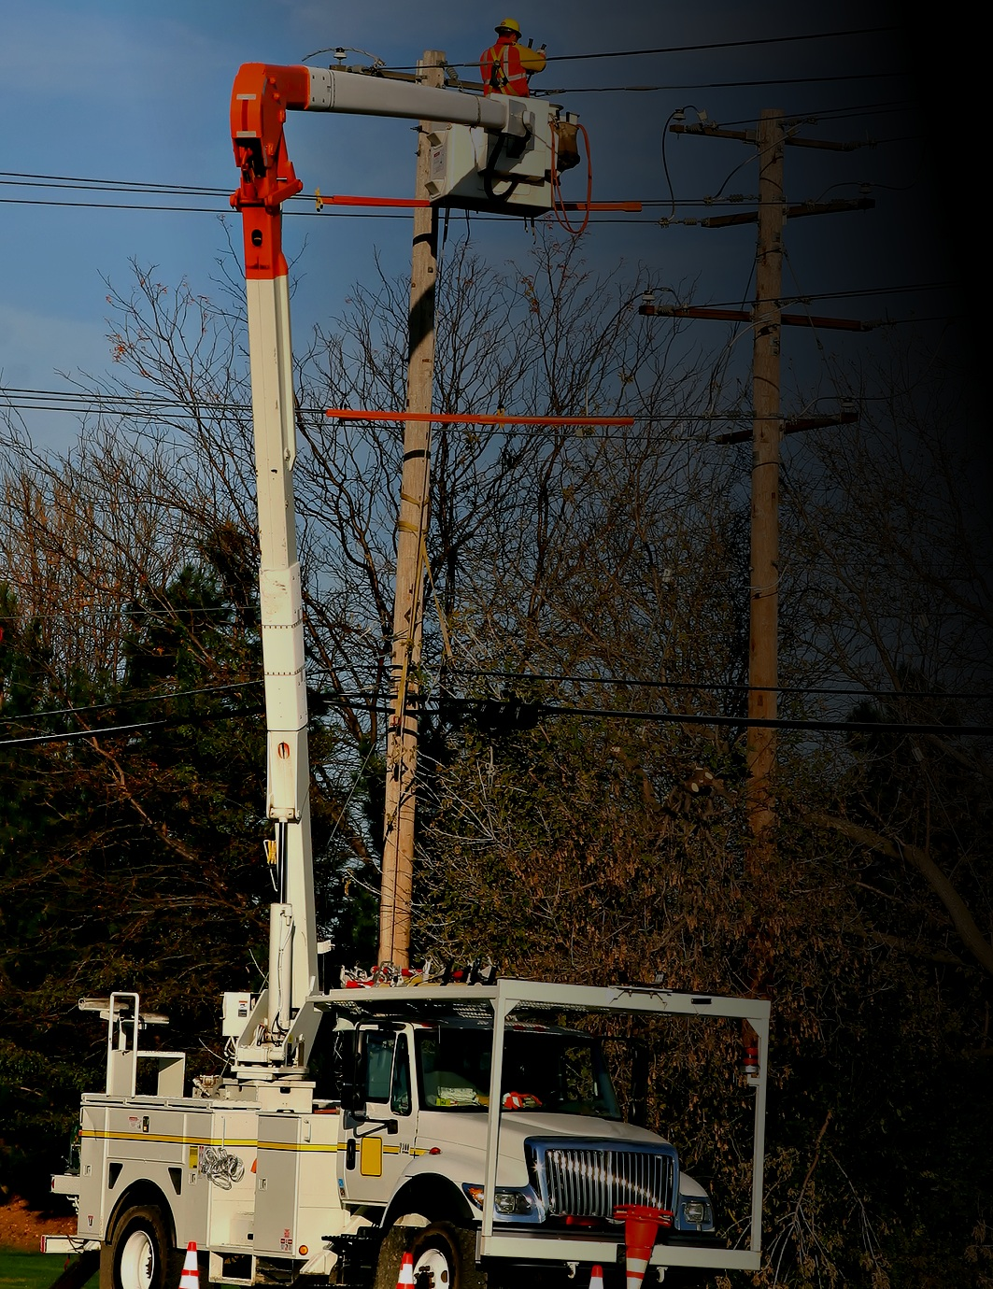

**Aerial Lifts**

**Preventing tip-overs:**

* Do not exceed manufacturer-rated load capacity limits.
* Do not travel to a job with the lift in an elevated position.
* Set up proper work zone protection when working near traffic.
* Avoid excessive horizontal forces when working on elevated aerial lifts.