Name: Date:
- The onset of a micro-nap is easily predicted by a fatigued driver.
A. True
B. False

- Micro-naps can last any time from a split second to _______ seconds.
A. 10
B. 15
C. 20
D. 25
E. 30

- A vehicle cruising at 65 mph will travel over _________ yards during a 10-second micro-nap.

A. 100
B. 200
C. 300
D. 400

- Which portion of the line represents the time period during the afternoon when the human body is most predisposed to sleep?
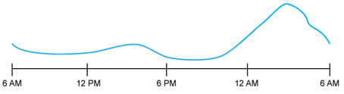

- Which portion of the line represents the time period during the night when the human body is most predisposed to sleep?
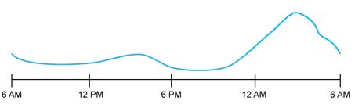

- Studies show that driving more than 11 hours during your overnight sleep gate increases the probability of a crash by 240%.
A. True
B. False

- Which chart below displays the approximate alertness level of a driver who is compensating for a lack of rest by drinking four cups of coffee over the course of their shift?

A.

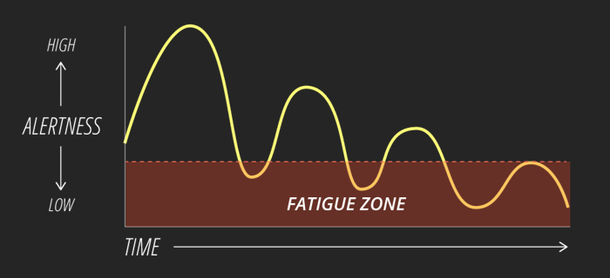

B.

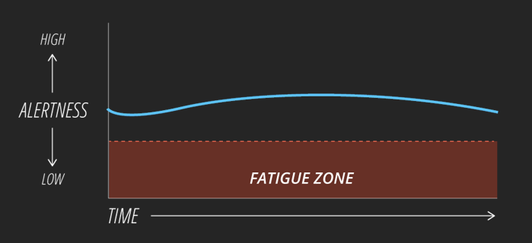

- Which of the following conditions are chronic sleep disorders?
A. Sleep apnea
B. Insomnia
C. Narcolepsy
D. Sleepy eye

- Get at least _____ hours of consecutive sleep every day or night.
A. 4 – 5
B. 5 – 6
C. 6 – 7
D. 7 – 8
E. 8 – 9

Answer Key
1. B
2. E
3. C
4.
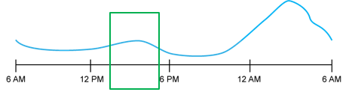

5.
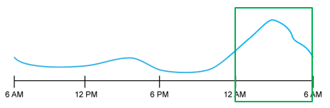
6. A
7. A
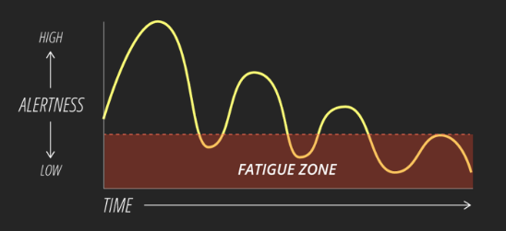
8. A, B & C
9. D

