Name: Date:
- Which sling configuration will provide the most balanced load?

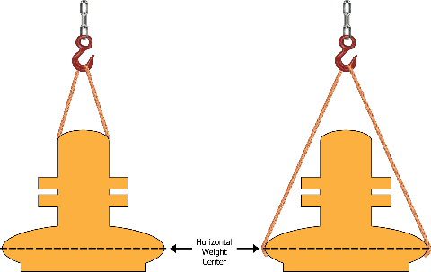
  - B.

- Which illustration is a basket hitch?
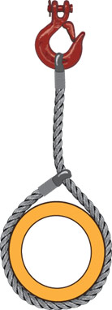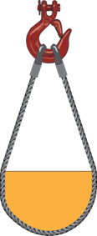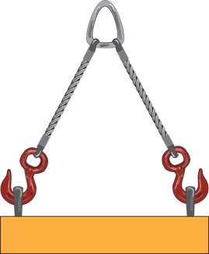
A. B. C.

- Sling attachments must have a rated capacity equal to or higher than that of the sling.

A. True
B. False

- Choose all that apply. Which of the following prohibited practices constitute a shock load?
A. Allowing a load to free fall while attached to the sling
B. Changing the load’s center of gravity during hoisting
C. Hoisting energized equipment
D. Making contact with power lines during a lift

- Choose all that apply. Which of the following environmental conditions can impact the safety of a lifting operation?
A. Wine
B. Precipitation
C. Temperature
D. Power lines or other overhead obstructions
E. Uneven or unstable surfaces
F. Reactive chemicals

- If welding repairs or heat testing is performed on alloy steel chain, the slings must also be reconditioned and proof-tested by ____ prior to re-entering service.
A. A qualified rigger
B. The sling manufacturer or equivalent entity
C. A tree, truck, and trailer hitch
D. The authority having jurisdiction

7) Choose all that apply. In addition to the general inspection requirements, alloy steel chain slings must also be regularly inspected for ______.
A. Wear
B. Defective welds
C. Deformation
D. Shine
E. Increase in length

8) Any alloy steel chain slings that have been heated above _____ must be permanently removed from service.
A. 600˚ F
B. 800˚ F
C. 850˚ F
D. 900˚ F
E. 1,000˚ F

9) During an inspection of a 1 ¼” chain, a small point on a link is measured at 15⁄16”. Does this chain still meet the minimum allowable size standard?
A. Yes, this chain is still viable for service.
B. No, remove this chain from service.

10) When using a shackle attachment for a choker hitch, the eye-splice must loop around the ____.
A. Shackle bolt
B. Top of the shackle

11) Immediately removed from service any wire rope that shows ______ randomly distributed broken wires in one rope lay or ______ broken wires in one strand of one rope lay.
A. 5, 3
B. 5, 10
C. 10, 5
D. 15, 8

12) Do not use wire rope slings if, in any length of eight diameters, the total number of visible broken wires exceeds _____ of the total number of wires.
A. 3%
B. 5%
C. 10%
D. 20%

13) Non-fiber core wire rope maintains lift capacity at higher temperatures than fiber core wire rope.
A. True
B. False

14) Do not use any new or repaired metal mesh slings, including handles or other attachments, until they have been proof-tested by the manufacturer or equivalent entity to at least ______ times their rated capacity.
A. 1.25
B. 1.5
C. 1.75
D. 2

15) Which of the following metal mesh slings is the best choice for lifts in extreme temperature environments?
A. Non-elastomer impregnated metal mesh
B. Polyvinyl chloride or neoprene impregnated metal mesh

16) Choose all that apply. Which of the following criteria would necessitate a removal of a metal mesh sling from service?
A. A broken weld or broken brazed joint along the sling edge
B. Reduction in the wire’s diameter of 25% due to abrasion or 15% due to corrosion
C. Lack of flexibility caused by distortion of the fabric
D. Ten randomly distributed broken wires in one rope lay, or five broken wires in one strand of one rope lay
E. Distortion of either handle out of its plane

17) When tying an eye splice with synthetic fiber rope, you must have a minimum of _______ tucks.
A. 3
B. 4
C. 5
D. 6

18) A sailor’s knot is an adequate substitute for a splice.
A. True
B. False

19) The required minimum clear length of rope between eye splices is equal to ____ times the rope’s diameter.
A. 3
B. 5
C. 10
D. 20

20) Use of repaired or reconditioned fiber rope slings is strictly prohibited.
A. True
B. False

21) According to the label, what is the sling above made of?
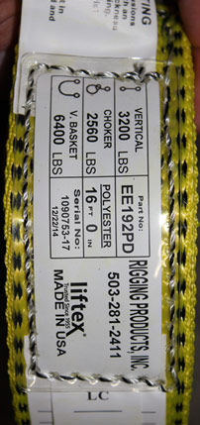
A. Polypropylene
B. Polyester
C. Nylon

22) Nylon web slings are not to be used where fumes, vapors, sprays, mists, or liquids of acids or phenols are present.
A. True
B. False

23) Choose all that apply. Which of the following conditions warrant a removal of a synthetic web sling from service?
A. Acid or caustic burns
B. Melting or charring of any part of the sling surface
C. Snags, punctures, tears, or cuts
D. Broken or worn stitches
E. Distortion of fittings

24) Use of the headache ball, hook, or load to transport personnel is acceptable if the worker is adequately harnessed.
A. True
B. False

25) If there is any possibility of employees occupying the work space below the lifting activity, the hook must _____.
A. Have self-closing safety latches or equivalents
B. Have an identifiable red color
C. Have an 80-decibel alarm mechanism

26) A multiple lift rigging assembly must not carry more than ____ members at a time.
A. 4
B. 5
C. 6
D. 7

27) Using the required 5-1 safety factor for a multiple lift rigging, what is the permissible working load for an assembly with a 10,000 lb minimum breaking strength?
A. 200
B. 2,000
C. 5,000
D. 50,000

28) Which hand signal indicates a command to hoist the load?
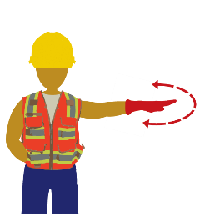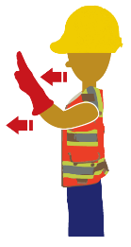
A. B. C.

29) Which hand signal indicates an emergency stop command?

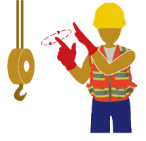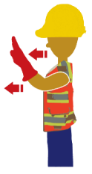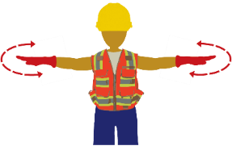
A. B. C.

30) Which hand signal indicates a command to move slowly?

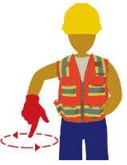
A B C

31) Which hand signal indicates a command to swing?

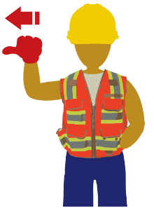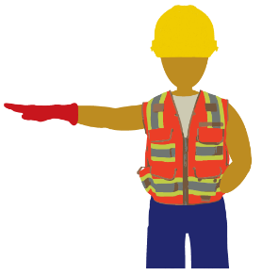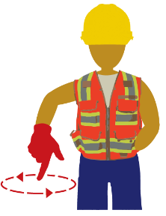
- B. C.

Answer Key
1. A
2. B
3. A
4. A & B
5. A, B, C, D, E & F
6. B
7. A, B, C & E
8. E
9. B
10. A
11. C
12. C
13. A
14. B
15. A
16. A, B, C & E
17. B
18. C
19. C
20. A
21. B
22. A
23. A, B, C, D & E
24. B
25. A
26. B
27. B
28. A
29. C
30. A
31. B

