Name: Date:
- Ergonomics principles can be applied through tools, instruments, workstations, and work practices.
A. True
B. False

- WMSDs are injuries to ________.
A. Organs
B. Soft tissue
C. Hard tissue
D. The epidermis

3) A WMSD typically results from a single, traumatic event.
A. True
B. False

4) The most common type of injury in the workplace is ________.
A. Tendonitis
B. A bone fracture
C. A cut or laceration
D. Muscle sprains, strains, or tears

5) Choose all that apply. It is recommended to take periodic breaks from ______.
A. Excessive force
B. Repetitive motion
C. Excessive vibration
D. Extreme temperatures
E. Crouching and kneeling

6) Choose all that apply. Examples of neutral alignment include _____.
A. Wrists bent at angles
B. Head looking forward, not tilting
C. Elbows extended away from the body
D. When standing, aligning ears, shoulders, hips, knees, and ankles

7) Lift with the ______.
A. Legs
B. Back
C. Arms
D. Waist

8) Localized vibrations are typically experienced in _______ when operating power tools.
A. The whole body
B. Legs and feet
C. Hands and arms
D. The back and shoulders

9) Recreational sports outside of work are always beneficial to your health.
A. True
B. False

10) Employees performing identical tasks under the same conditions have the same susceptibility to WMSDs.
A. True
B. False

11) Choose all that apply. Ergonomics programs have the benefit of _____.
A. Reducing the number of people reporting ergonomic hazards
B. Reducing absenteeism
C. Lowering worker compensation costs
D. Improving work quality

12) Report any signs or symptoms of WMSDs as soon as they develop.
A. True
B. False

13) Match the type of control with the example.

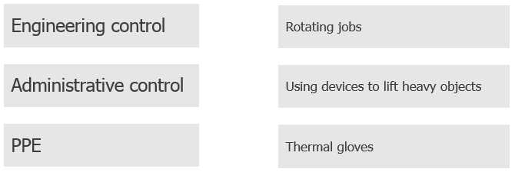

14) The most effective type of controls are ______.
A. PPE
B. Engineering controls
C. Administrative controls

Answer Key
1. A
2. B
3. B
4. D
5. A, B, C, D & E
6. B & D
7. A
8. C
9. B
10. B
11. B, C & D
12. A
13.
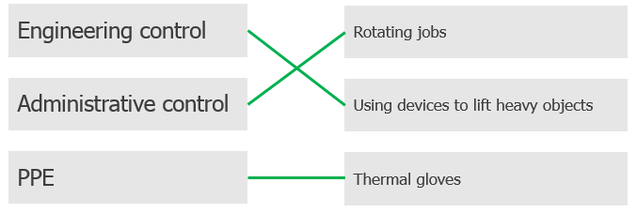
14. B

