Name ____________________________________________________ Date_________________

1) Which of the following are considered fall hazards? Select all that apply.

A. Unprotected Edges

B. Aerial Lifts

C. Dangerous Equipment

D. Trenches

E. Floor Openings

F. Elevated Platforms

G. Skylights

2) True or False? Identifying fall hazards is everyone’s responsibility.

- True

- False

3) Match the following descriptions with the corresponding Site Controls.
1. This prevents employees from falling from unprotected edges and tools from falling below.
2. These prevent employees from hitting the ground in the event of a fall when a personal fall protection system is not practical.
3. These provide a safer working surface when a fall hazard cannot be eliminated.
4. This system relies on someone monitoring when conventional types of FP are impractical.
5. A safety measure that prevents injuries from formwork below.
6. These block off areas restricted to authorized personnel.
7. These controls warn employees of the fall hazards and restricts access to authorized personnel.
8. This regular practice ensures walking surfaces are clean and orderly.
A. Housekeeping
B. Warning Signs
C. Rebar Caps
D. Guardrails and Toeboards
E. Warning Lines
F. Aerial Lifts
G. Safety Nets
H. Safety Monitoring

4) What are the 3 components of a Personal Fall Arrest System? Click on each one to select them.

A. Connecting Device
B. Anchor
C. Body Harness
D. Hard Hat
E. Shin Guards

5) Match Personal Fall Protection System with the corresponding description.
1. Consist of a roof anchorage, a support rope, a descent device, a carabiner or shackles, and a chair or seatboard.
2. Designed to suspend an employee at a work location and limit the free fall to 2 feet or less.
3. Designed to prevent falls from a fixed ladder system and consists a of lanyard, connectors, carriers, safety sleeves, and a body harnesses.
4. Designed to prevent the user from reaching an area in which a free fall could occur so that no free fall is possible.
A. Travel Restraint

B. Rope Decent

C. Fixed Ladder

D. Work Positioning

6) How many pounds per person must anchors be capable of supporting?

A. 2000 pounds
B. 5000 pounds
C. 1000 pounds

7) When should you perform an inspection of your personal fall arrest system?

- Once a Day
- Once a Year
- Before Each Use
- Once a Month

8) When you perform an inspection of your personal fall arrest system, what do you need to be looking for? Select all that apply.

- 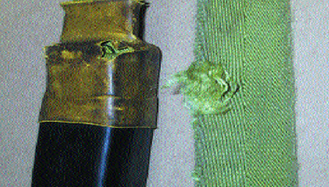
- 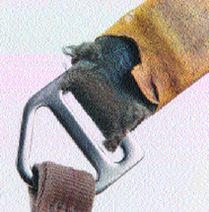
- 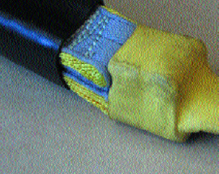
- 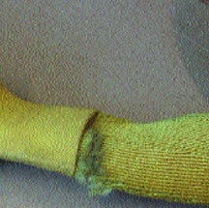

9) While performing an inspection of the body harness, you discover there is no label. What should you do with the harness?

- Remove it from use
- Put it on and use it
- Continue the inspection

10) After a fall and rescue, which of the following should happen? Select all that apply.

A. Fall Victim Receives Medical Attention
B. Body Harness and Lanyard Taken Out of Use
C. Other Components Inspected by a Competent Person
D. Nothing, Back to Work as Usual

Answer Key
1. A, B, C, D, E, F, G
2. True
3. A – 8, B – 7, C – 5, D – 1, E – 6, F – 3, G – 2, H – 4
4. A, B, C
5. A – 2, B – 1, C – 3, D – 4
6. B
7. C
8. A, B, C, D
9. A
10. A, B, C

