Name: Date:
- Study the label to the right. What piece of information is missing?
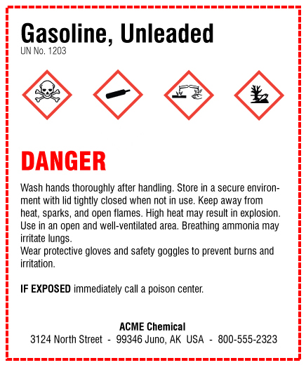
A. A signal word
B. Pictograms
C. A hazard statement
D. A product identifier
E. Precautionary statements

- The precautionary statement on a hazardous chemical label provides accident prevention, accident response, and storage information.
A. True
B. False

- Which pictogram shown indicates a health hazard? Choose the correct icon.

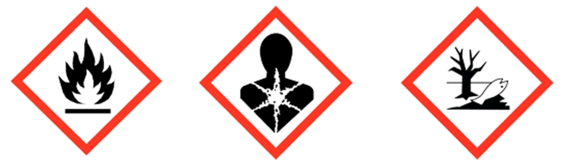
- B. C.

- When hazardous materials are transferred into secondary containers, the only requirement is a product identification sticker.
A. True
B. False

- Choose all that apply. Labels for pipes carrying hazardous substances must _______.
A. Identify material being carried and direction of flow
B. Be placed at all junctions and fittings
C. Be color-coded, based on the hazard category
D. Be placed 50 feet or closer apart

Answer Key
1. C
2. A
3. B
4. B
5. A & B

