Name: Date:
1) Choose the best answer. What kind of hazardous motion is caused by gears?
A. Reciprocal
B. Transverse
C. In-running nip points
D. Cutting
E. Punching, shearing, or bending

2) Choose all that apply. Which types of motion can catch you in the machine?
A. Rotation
B. Reciprocal
C. Transverse
D. In-running nip points
E. Punching, shearing, or bending

3) When is it appropriate to remove a guard from a machine during operation?
A. When making adjustments to the machine
B. In order to see the machine processes better
C. When your supervisor tells you that it is okay
D. Never

4) Every moving part on a machine must be guarded.
A. True
B. False

5) Choose the best answer. What is the point of operation?
A. The point at which the operator works on the machine
B. The point at which the machine works on the material
C. The point from which energy is transmitted to the part of the machine performing the work
D. None of the above

6) Study the machinery shown. The gear elements of the conveyer machinery are considered the _____________.

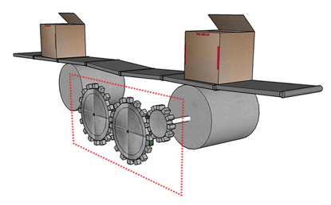

A. The point of operation
B. The power transmission apparatus
C. Other moving parts

7) Guards must be fastened so that they require a tool for removal.
A. True
B. False

8) Which is the best choice for an interlocking guard?
A. A key-activated safety interlock
B. An interlock with a limit switch
C. An interlock with a proximity switch
D. An interlock with an overload sensor

9) When a single component failure will not prevent stopping action from triggering, this is called ________.
A. A failsafe
B. Safeguarding
C. Control reliability
D. Sufficient stopping power

10) A light curtain is a type of fixed guard.
A. True
B. False

11) An e-stop is a sufficient safeguard by itself.
A. True
B. False

12) Choose all that apply. What should employees be prohibited to wear around machinery?
A. Jewelry
B. Loose clothing
C. Untied long hair
D. None of the above

13) Choose all that apply. Which hazards are caused by conveyor systems?
A. Pull-in hazards
B. Cutting hazards
C. In-running nip points
D. Crush hazards
E. None of the above

Answer Key
1. C
2. A, B, C, D & E
3. D
4. A
5. B
6. B
7. A
8. A
9. C
10. B
11. B
12. A, B & C
13. A, C & D

